Figure 1
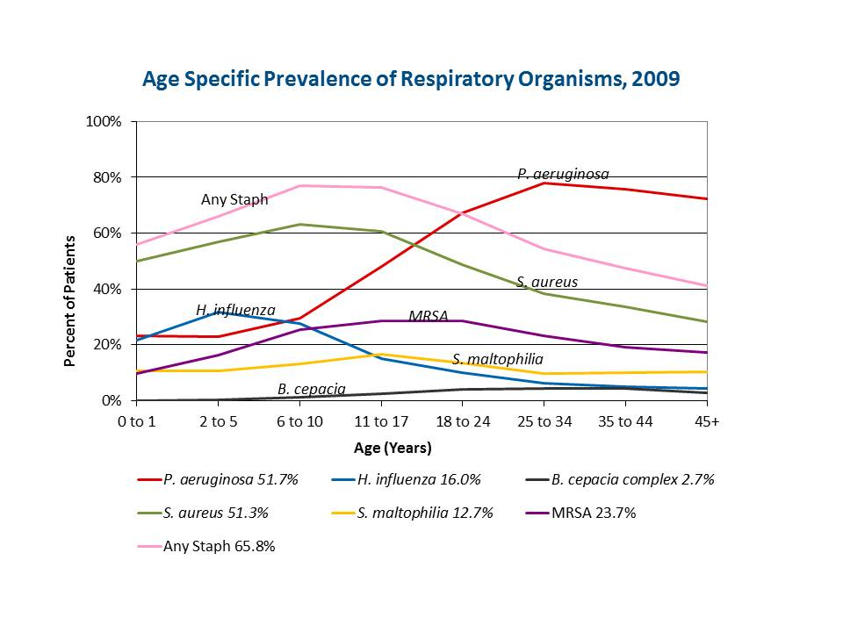

Reprinted with permission from:
Cystic Fibrosis Foundation Patient Registry
2009 Annual Data Report
Bethesda, MD
©2009 Cystic Fibrosis Foundation

